Lab 8

Goal: Use switches to control the output of an RGB LED
Cycle through 8 color combinations in 1 second intervals
Flash red
Flash green (at a different pace than red)

We had a board with an LED on it which was controlled by 3 pins. Each pin controlled the R/G/B output

Step 1:
Design the logic for the multicolor cycle.
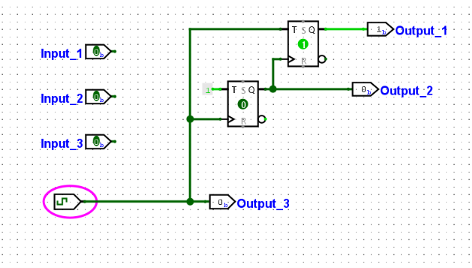
I designed this so when the clock moved output 3 would cycle at the same time, output 2 would cycle one rotation slower, and output 3 would cycle two rotations slower.

This can be simplified by just using a counter:
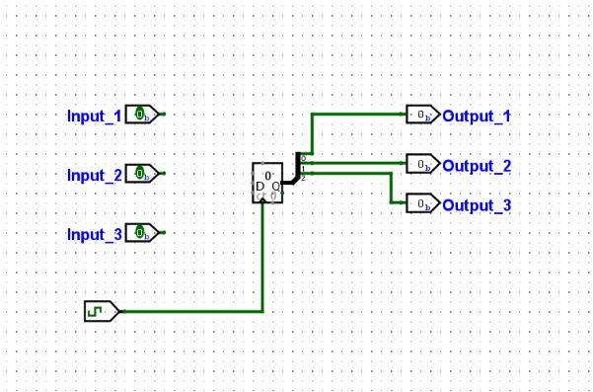

Step 2:
Now I want to control outputs with 2 switches. So if the switches are 11, it will output the multicolor cycle. If 10 it will blink green and if 01 blink red.

I first designed this: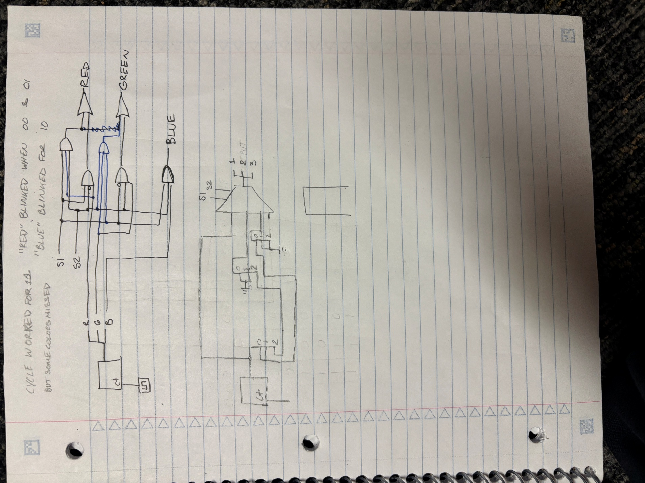
Which worked as expected for the most part, but when both switches were off, red still blinked. I also had mixed up the pins but that is an easy fix. I’m wondering if I attached a switch to the wrong pin on the and gate.

This was the final design:
A multiplexor was the simplest design. My use of and / or gates was redundant at points.

